BSK®-Aeration Turbine
IMPORTANT INFORMATION AS BASIS FOR AN OFFER

Preliminary Information
With the following questionnaire we would like to learn as much as possible about the current project task, for which we are pleased to establish an offer for BSK®-aeration turbines. Although maybe not all information can be submitted, we ask you to fill in as much information as possible so that we can learn more about the basic conditions of the project. Should the questionnaire could be completed by drawings or photos (if the wastewater treatment plants do already exist), would this be very helpful for a better understanding of the project.

General Data

2.1 | Name:

2.2 | Company name:

2.3 | Street:

2.4 | Post code / town:

2.5 | Country:

2.6 | Phone:

2.7 | Skype:

2.8 | e-mail:

2.9 | Others:

3. Project Data

3.1 | Country of installation:

3.2 | Project name / project location:

3.3 | Kind of demand: | public tender  private demand (e.g. industry)  others

3.4 | Retrofit or new building of a wastewater treatment plant? | retrofit |  | new installation

3.5 | Floating or fixed installation?  (floating = installation at great varying water level,  e. g. SBR;  fixed installation = installation on top of a bridge) | floating |  | fixed installation

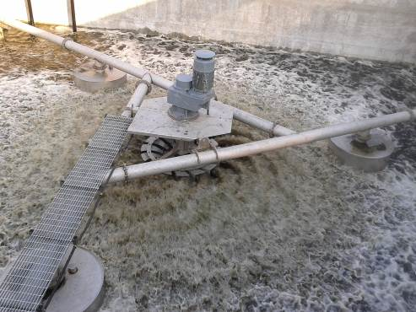  floating installation | 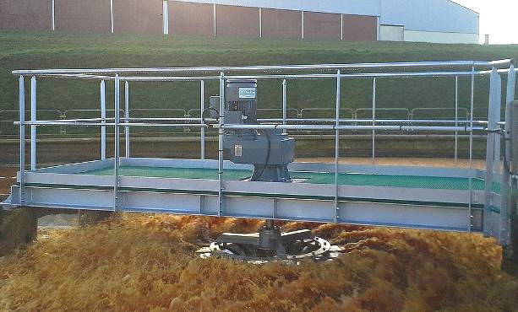  installation on top of a bridge

3.6 | Quantity of aeration systems: |  | ea.

3.7 | Kind of sewage:

3.8 | Altitude a.s.l.: |  | m a.s.l.

3.9 | Shape of basin: | round, diameter = |  | m
 |  | rectangular, L x W | x m

3.10 | Water depth / water level (WL): | constant | m
 |  | different WL from up to m

3.11 | Distance between top of bridge and WL: |  | m

3.12 | Requested O₂-input capacity (actual oxygen required - AOR): |  | kgO₂/h

3.13 | Operation time per day: | continuous aeration |  | h/d

3.14 | Requested speed regulation: | none, only constant speed
frequency converter for continuously speed
regulation (recommended)
 |  | others

3.15 | Given technical data / requests regarding drive (motor and gearbox: | service factor drive: 1.5 2.0 2.5  other requests:
 |  | bearing lifetime: |  | h
 |  | ISO-class F H
 |  | protection class: IP55 IP65
 |  | thermistors: yes no
 |  | oil leakage control: yes no
 |  | efficiency class motor: IE2 IE3 IE4
 |  | colour request: yes no
 |  | If yes: RAL:

3.16 | Turbine and shaft material: | AISI 304 (A2) |  | AISI 316 (A4)

3.17 | Other requirements:

4. General Offer Requests

4.1 | Offer should be submitted until: | immediate  latest until  occasionally

4.2 | Project background: | only design study
 |  | concrete project case
 |  | current tender

4.3 | Kind of request: | for own demand
 |  | customer request
 |  | we are a design company
 |  | we are reseller

4.4 | Urgency of project: | expected realisation in year  urgent demand, delivery as soon as possible  undefined

4.5 | Situation of competition: | unknown

4.6 | Scope of offer: | only aeration turbines
turbines with drive system
(according to following graphic)
 |  | other requests:

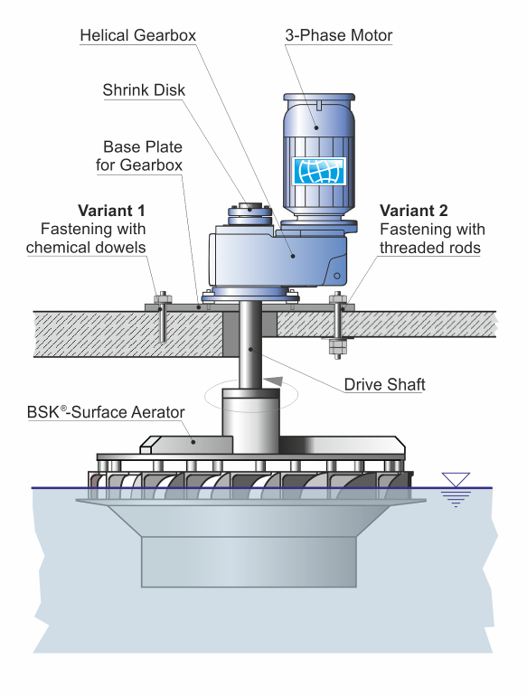

4.7 | Calculation of price / commercial  basis for offer : | ex works Biogest International
 | Calculation of price / commercial  basis for offer : | FOB North sea port (port of departure)
 |  | CIF port of arrival named
 |  | others

4.8 | Language of offer: | English  German  others _________________________

4.9 | Requested additional material with respect to the offer: | flyer BSK®-Turbine
 | Requested additional material with respect to the offer: | data sheet of turbine
 |  | reference list
 |  | example installation drawing
 |  | others

4.10 | Following information material is  attached to this questionnaire: | Extract of technical specification
 |  | Extract of tender
 |  | project drawing/s
 |  | project photo/s
 |  | others

4.11 | Person for checkback: | name:
 |  | direct dial:
 |  | e-mail:

……………………………………………………
(Place, Date)

Biogest International GmbH
Berthold-Haupt-Str. 37
D - 01257 Dresden
Fon:
+49 (0) 3 51 3 16 86 -0
Fax:
+49 (0) 3 51 3 16 86 -86
E-Mail:
info@biogest-international.de
Internet:
www.biogest-international.de

