BSK®-Clear Water Decanters for SBR-WWTPs
Questionnaire as Basis for a Quotation

Basic Information
1.1 | Project code | Project no.:

1.2 | Your name :

1.3 | Your company (name):

1.4 | Company address: | postal code | town
 |  | street
 |  | country

1.5 | Your office phone number:

1.6 | Your mobile phone number:

1.7 | E-Mail-address:

1.8 | Other:

Detailed Project Information
2.1 | Project location: | country: | town:

2.2 | Expansion or new construction? | expansion | new construction

2.3 | Quantity of SB-Reactors: |  | each

2.4 | Quantity of decanters per reactor: |  | each

2.5 | Kind of reactor: | circular | rectangular

2.6 | Imbedding of reactor below ground: |  | m

2.7 | Geometrical figures of the  SB-Reactor(s): | diameter (circular tanks): | m
2.7 | Geometrical figures of the  SB-Reactor(s): | length x width at rectangular/ square tank(s):  x | m
2.7 | Geometrical figures of the  SB-Reactor(s): | clear height of reactor: | m

2.8 | Material of SB-Reactor: | concrete | precast concrete
 |  | glass coated steel | steel
 |  | others:

2.9 | Drawing of SB-Reactor / project: | attached  not available  freehand-sketch attached

2.10 | Covering of reactor: | without cover | with cover

2.11 | In case of cover: Kind of covering: | plastic dome | concrete floor
 |  | others:

2.12 | Hydraulic performance data: | discharge quantity/reactor: | m³
2.12 | Hydraulic performance data: | decanting time:  requested number of decanters/reactor:  redundancy of decanters is required | h  ea.

2.13 | Special requirements with respect to the discharge hydraulic:  (recommendation: decreasing of discharge quantity) | discharge quantity must be relatively constant  discharge quantity should decrease with increasing proximity to the sludge level (to avoid whirling up close to the sludge level)
 |  | max. allowed discharge quantity per reactor  (by possible limits at the discharge side): | m³/h

2.14 | Maximum water level (“TWL”):  Minimum water level (“BWL”):  Distance of the effluent pipe above bottom of tank (“OL”):  (Please see following illustration) | not less than  not more than  exactly  no preference | m  m  m  m  m

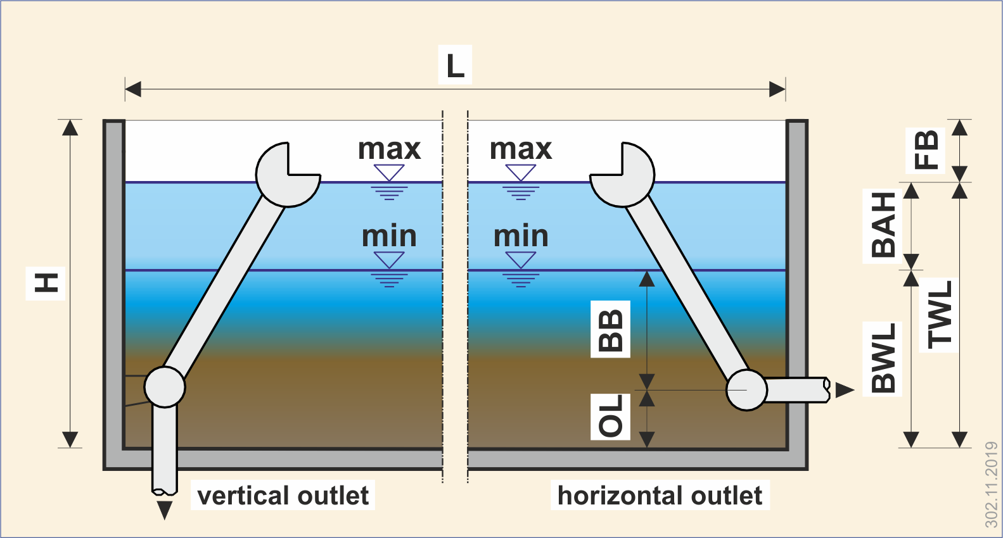

2.15 | Direction of discharge pipe: | horizontally through the reactor wall  vertically downwards through the reactor bottom

2.16 | Decanter-pipe end designed as: | DIN-flange  free pipe end with pipe coupling

2.17 | Kind of outflow condition behind the  decanter: | free discharge without counterpressure  discharge into a storage basin with max. m  back pressure above bottom of the reactor

2.18 | Requested material for all parts of the decanter (parts below water (wetted parts): | stainless steel, 1.4301 (V2A) – AISI 304  stainless steel, 1.4571 (V4A) – AISI 316  special material request:

2.19 | Ex-zone | yes, according to ATEX zone  no

2.20 | Available electrical supply: | 400 V / 50 Hz / 3 phases – or
2.20 | Available electrical supply: | special conditions: Volt / Hz

2.21 | Shadow temperatures (summer/winter)  and humidity: | maximum summer temperature: + °C  minimum winter temperature: °C  low air humidity  high air humidity

2.22 | Specific requests for operation control (immersion- and operation control): | standard control with limit switches (winch)  immersion control with conductive sensor  immersion control with pressure sensor  sludge density control (turbidity sensor)

2.23 | Other requested equipment – individual requirements of our customer:  (if necessary, detailed requirements could be  attached to this questionnaire)

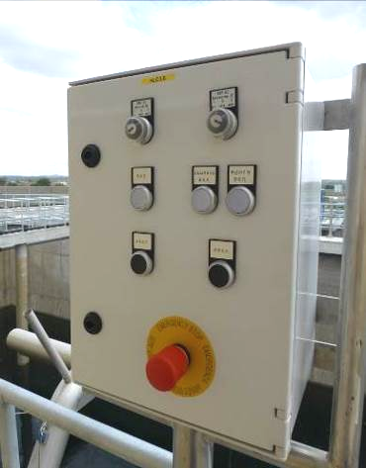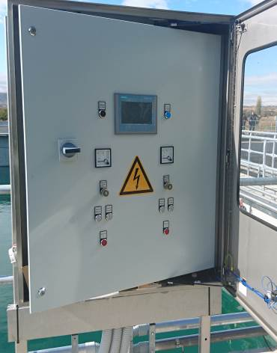
Example of a local switchbox for one BSK®-decanter. The cabinet could be produced by use of glass fiber reinforced plastic (GRP) or stainless steel. Moreover, the front side could be covered by a moveable door with glass-window (for protection of dust).
Example of a local stand-alone control system (plug and play), operating two (2) BSK®-decanters completely independent to the customer’s PLC. This cabinet is equipped with a moveable cover with glass window. glass-window (for protection of dust).

2.24 | Electrical control of the decanting process: | a local control of the winch-operation is provided by our customer (based on information by Biogest International)  a local switchbox for test-run shall be delivered by Biogest International  a complete control panel including PLC and all necessary equipment for operating the decanter shall be delivered by Biogest International  additional requirements or specific requests:

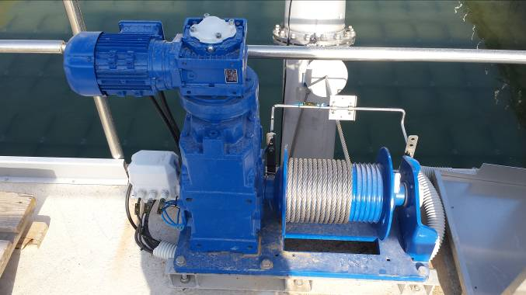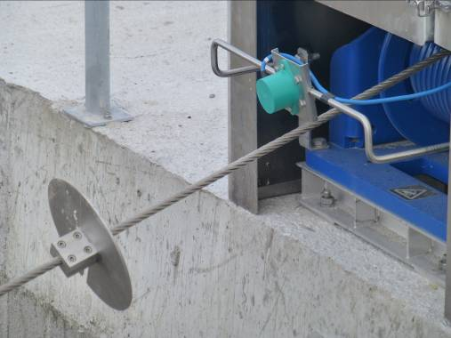
BSK®-decanting winch including drum, electrical drive and limit switchbox Emergency limit switch to prevent uncontrolled lifting
of the decanter

3. Additional Information and Specific Requests for our Quotation

3.1 | Project background: | only feasibility study  current project (shortly tendered)  already published public tender  already published private tender  project realization time frame (MM/YYYY): /

3.2 | Individual background: | decanter for own needs (I am plant operator)  planning office (wants to include BSK®-decanters)  reseller (we are buying and selling for a concrete project)  others:

3.3 | Requested delivery time (in case of order): | months after placement of the order

3.4 | Requested delivery term:  (Incoterms 2010) | ex works (EXW) free carrier  delivered at place (DAP) free harbour (CIF)  name of harbour / delivery place

3.5 | Requested service performed by  Biogest International: | only supervision of assembly (assembly by customer)  including complete assembly  start-up and training of local personnel

3.6 | Technical documentation: | German English  French
 |  | digitally via e-mail printed - fold

3.7 | Language of offer: | German | English

3.8 | Required submittal date of quotation: | occasionally, not top-urgent, but latest at  asap, latest  Immediately!! We need the quotation until

3.9 | Additional documents to be added  as attachment of the quotation:  (please attach these documents to the offer) | info bulletin “BSK®-Decanter”  reference list  reference photographs
(mit dem Angebot zusenden)

3.10 | Attached documents / information  to complete this questionnaire: | technical specification  extract of tender documents  project drawing(s)

3.11 | Kind of delivery of the reque  sted quotation: | by e-mail by conventional mail

3.12 | Responsible person for this questionnaire and address for quotation: | name:  direct dial:  e-mail:

……………………………………………………
(Place) (Date)

